# Device APIs (Import & Export)

All data, both import and export, will tie into our existing database using Laravel. Work with the current dev admin to make sure the data imported is usable.

## **Initial Connection**

Upon connecting, import the entire user profile

* Name
* Age
* Gender
* Profile Image
* Fitness level
* Recovery %

Including sports profiles:

* Current HR Zones per sport (swim, bike, and run)
* Current Power Zones 1-7 for cycling
* Current FTP for cycling
* … all default user data

And historical data:

* Last 30 days of all workouts imported to our calendar

## **Import Devices**

In order of priority:

* Garmin
* AppleWatch
* Strava
* Polar
* FitBit
* Suunto
* Wahoo

## **Daily Import**

Import daily recovery after sleep

* Hr
* HRV
* Recovery score
* Time slept
* Quality of sleep
* How the user felt
* Etc

## **Import all activities**

Import all primary workout data points:

* Time
* Distance
* Overall Strain / Effort
* FTP
* Pace
* …

Along with all the raw data in a usable format. This is a key component of this project. We can easily import all raw data, but we need usable:

* Import continuous GPS, Strain, Pace, Elevation, Power, and HR throughout the workout as txt files?
* Import or convert time spent in training HR zones 1-5
* Import or convert time spent in power training zones for cycling 1-7
* Import or convert max strain, pace, power, and HR for 5 sec, 15 sec, 30 sec, 1 min,…
* …

For example - we need all the data points as shown in the Strava graph below and the Training Peaks images at the end of the document.

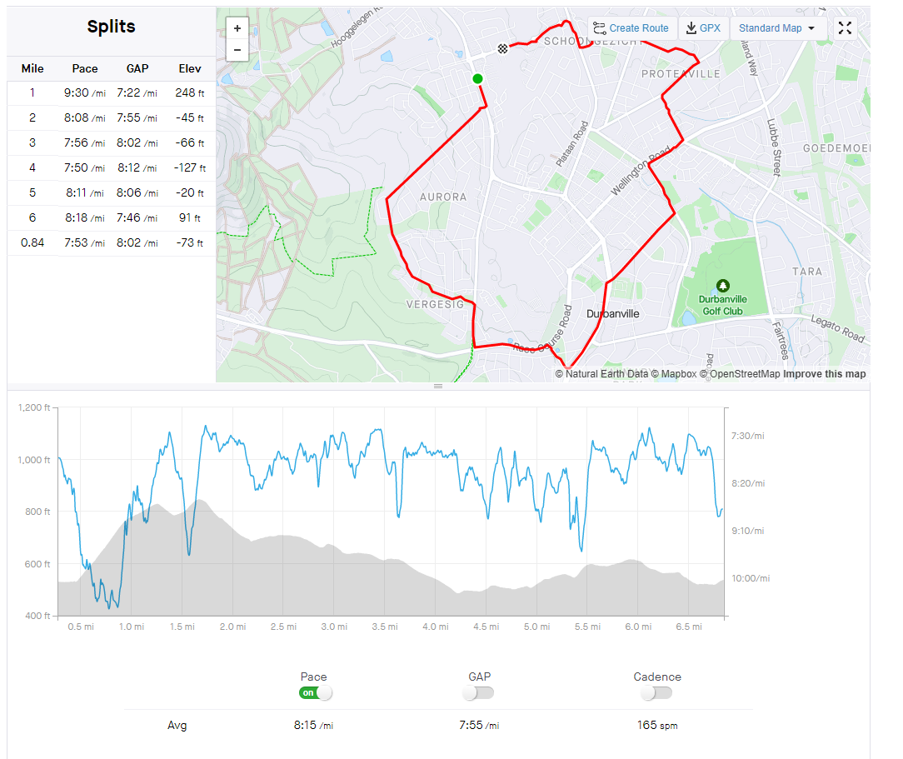

## **Export workout**

Must export as much workout data as allowed by each device, using the platform’s required format along with the way we currently format/style a workout in our app

Workout must sync with our app when completed

## **Export Devices**

In order of priority:

* Garmin
* AppleWatch
* Strava
* Polar
* FitBit
* Suunto
* Wahoo

## **Apple Watch app (optional project)**

Must match MySwimPro functionality

While matching our current app’s design

## Training Peaks Data Points

You can reference Training Peaks for a total list of data points. These are all the data points that we need imported into the DB from each device that can easily be displayed:

